**SIFT Features detected, Overlaid on Image –   
Image_1 & Image_3: *Features detected = 3238***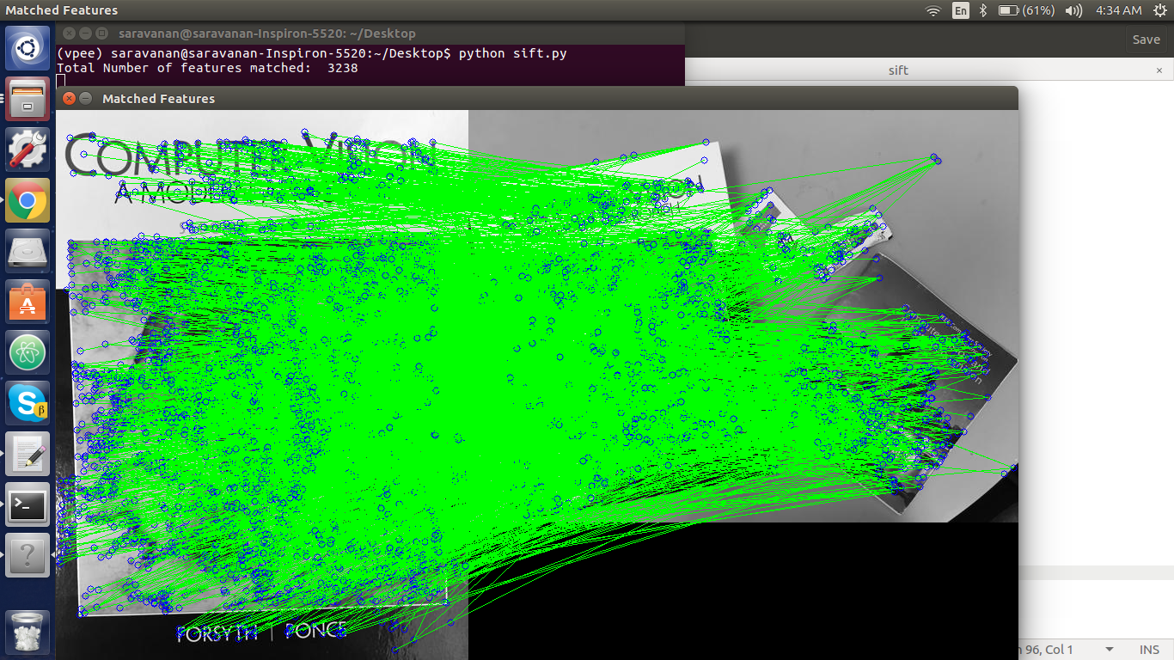 **Image_1 & Image_4: *Features detected = 3238***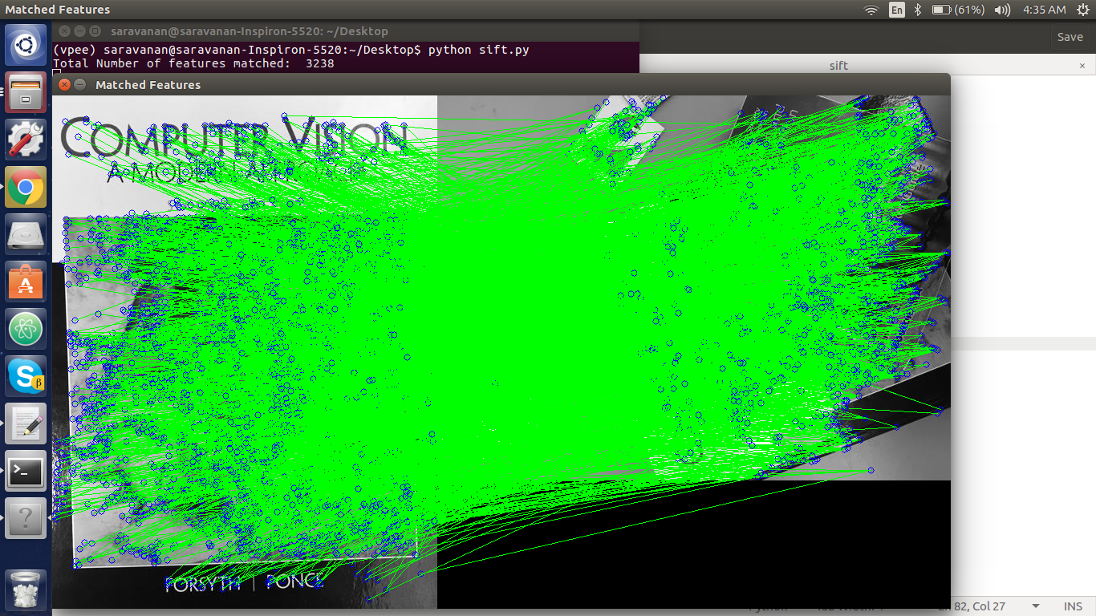

**Image_1 & Image_5: *Features detected = 3238***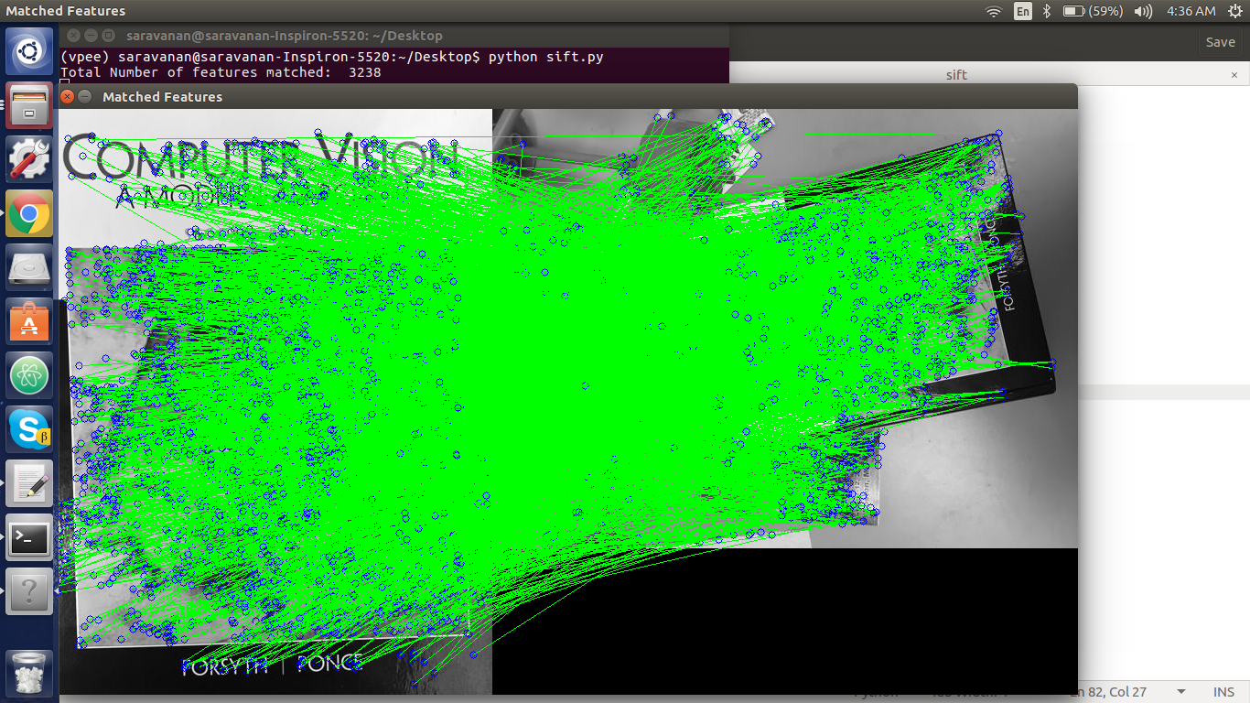

**Image_2 & Image_3: *Features detected = 2830*  
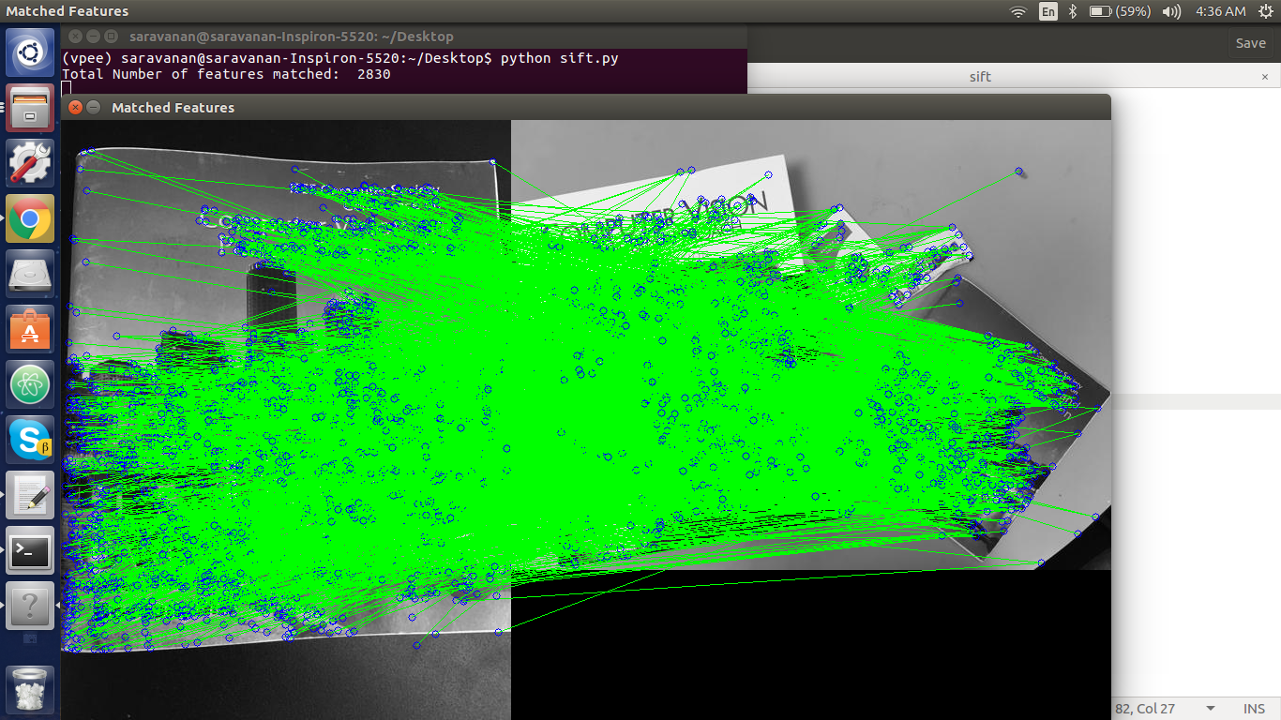**

**Image_2 & Image_4: *Features detected = 2830*  
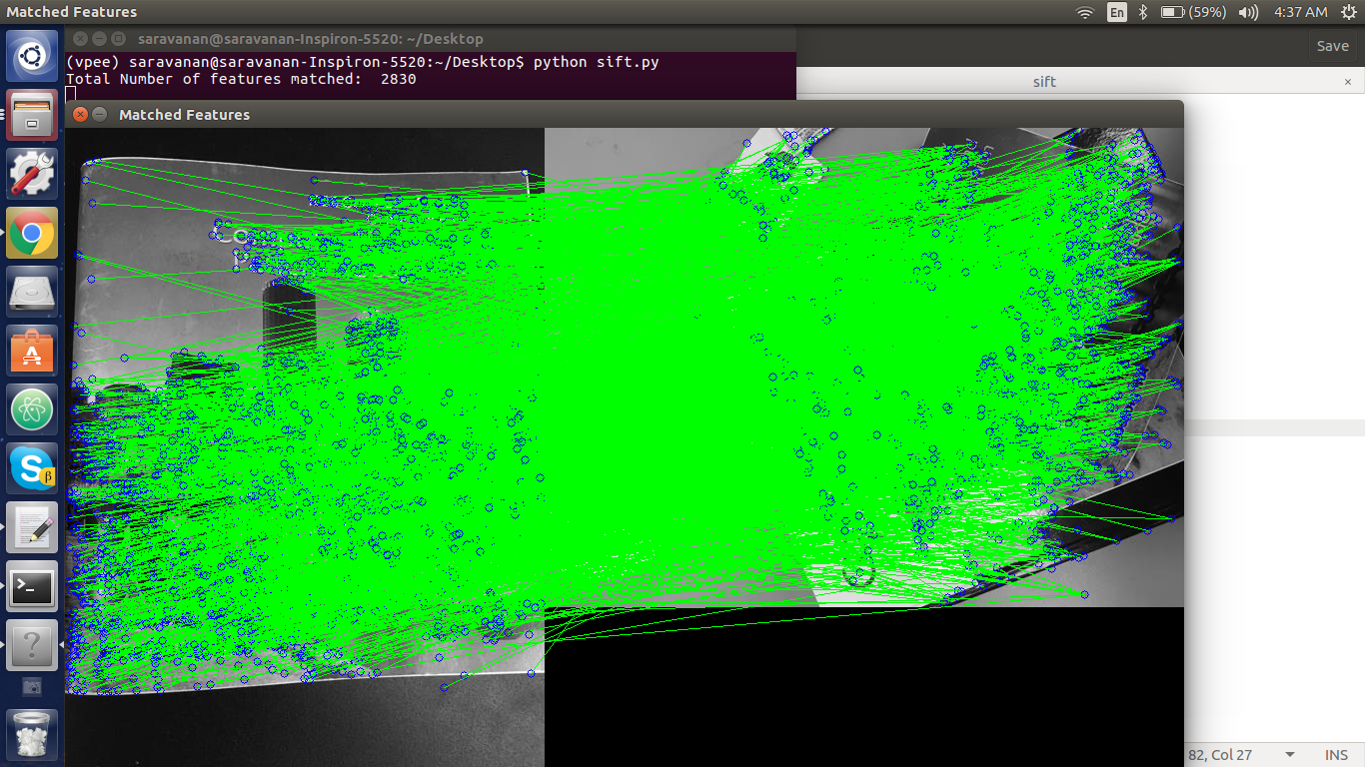**

**Image_2 & Image_5: *Features detected = 2830*  
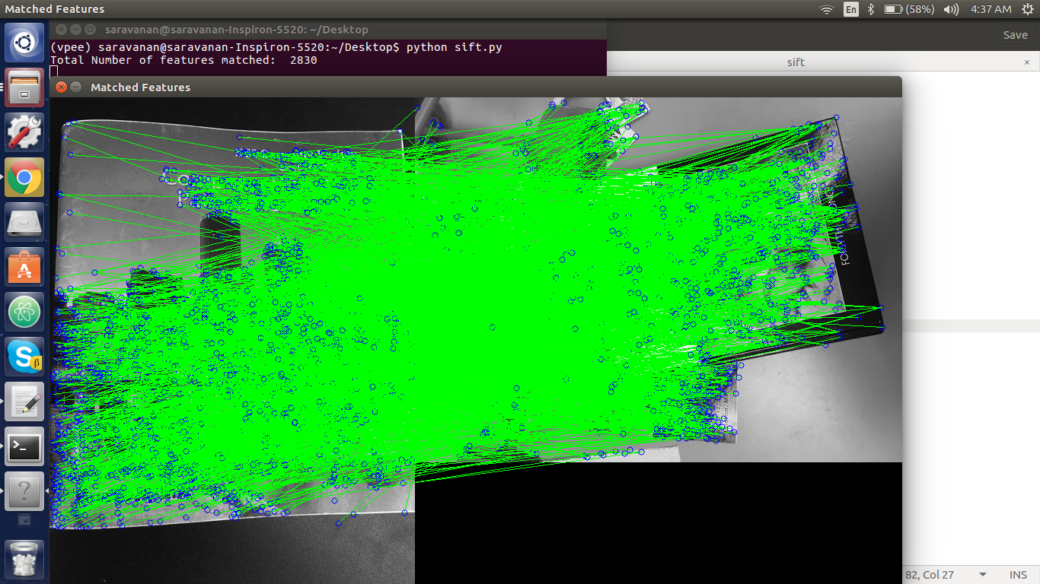**

**Top 20 scoring matches before RANSAC   
Image_1 & Image_3:  *wrong match count = 1*  
  
  
Image_1 & Image_4: *wrong match count = 1*  
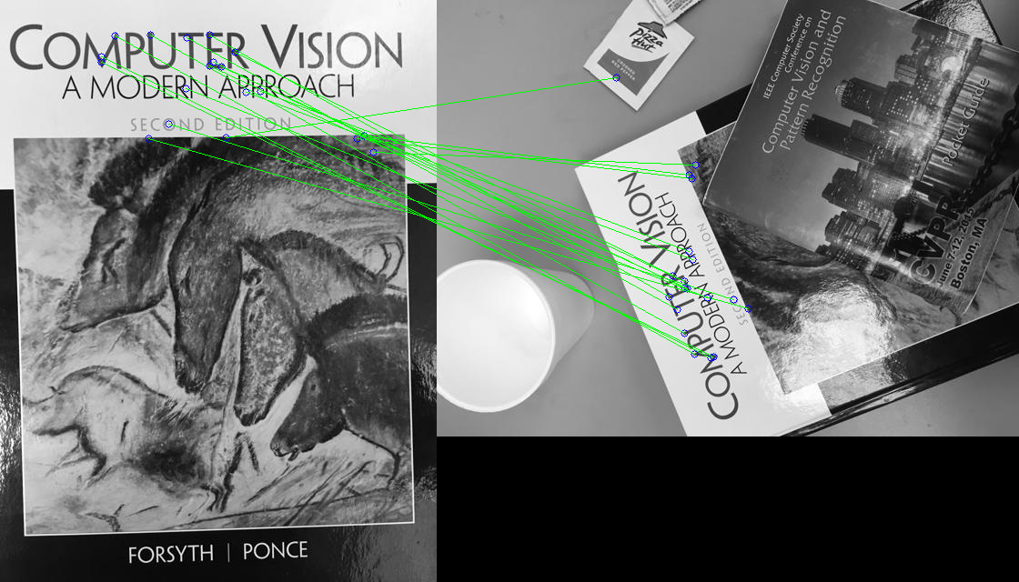  
  
  
  
  
  
Image_1 & Image_5: *wrong match count = 0*  
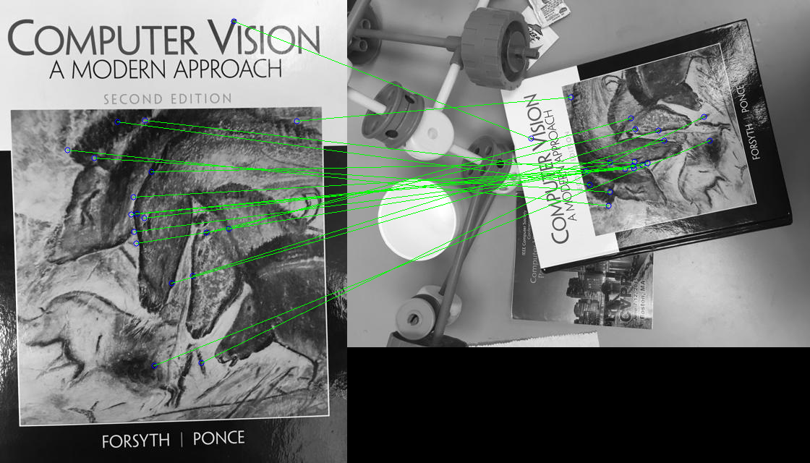  
  
Image_2 & Image_3: *wrong match count = 2*  
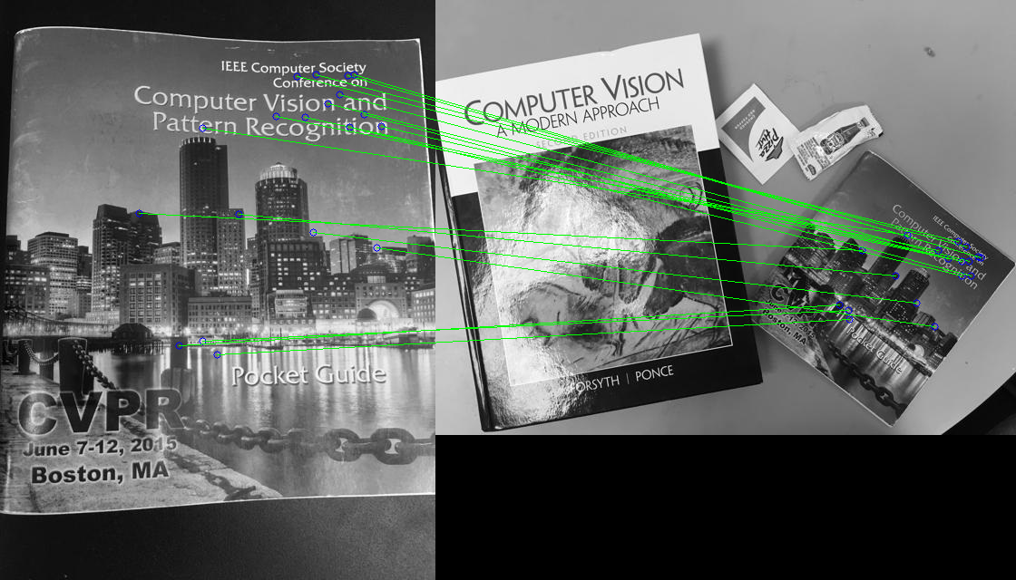  
  
  
  
  
  
  
Image_2 & Image_4: *wrong match count = 1*  
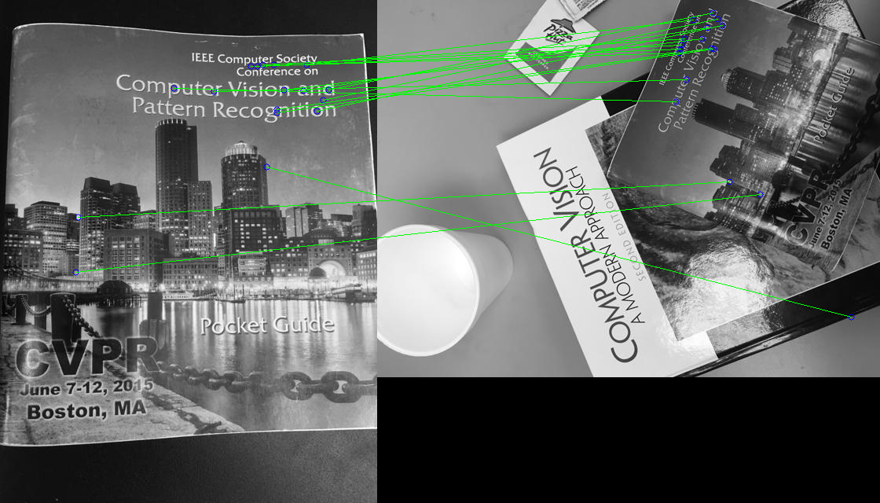  
  
Image_2 & Image_5: *wrong match count = 8*  
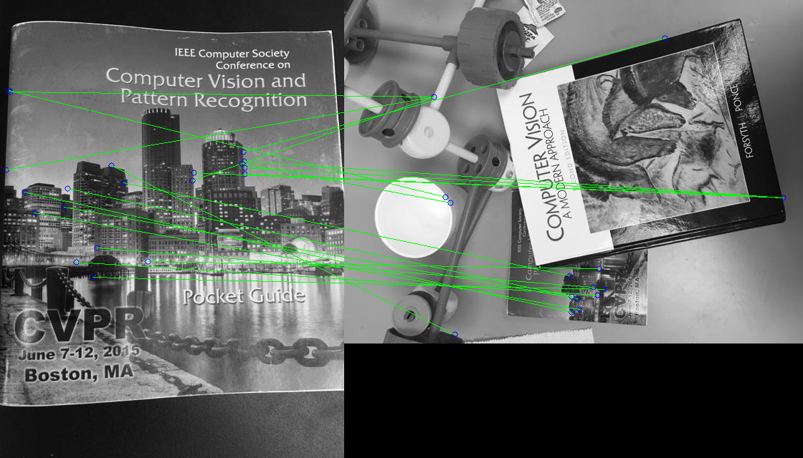**

**Top 10 scoring matches after Homography  
*wrong match count = ~0 for all cases*   
Image_1 & Image_3:  
  
Image_1 & Image_4:  
  
  
  
  
  
  
Image_1 & Image_5:  
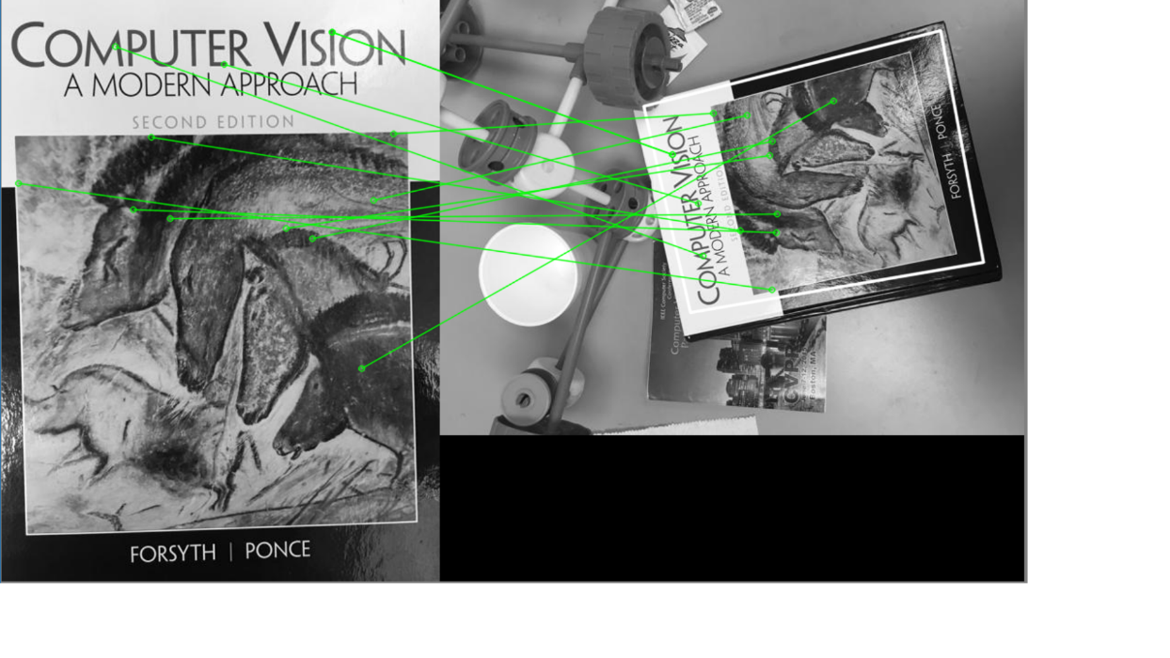  
Image_2 & Image_3:  
  
  
  
  
  
  
  
Image_2 & Image_4:  
  
Image_2 & Image_5:  
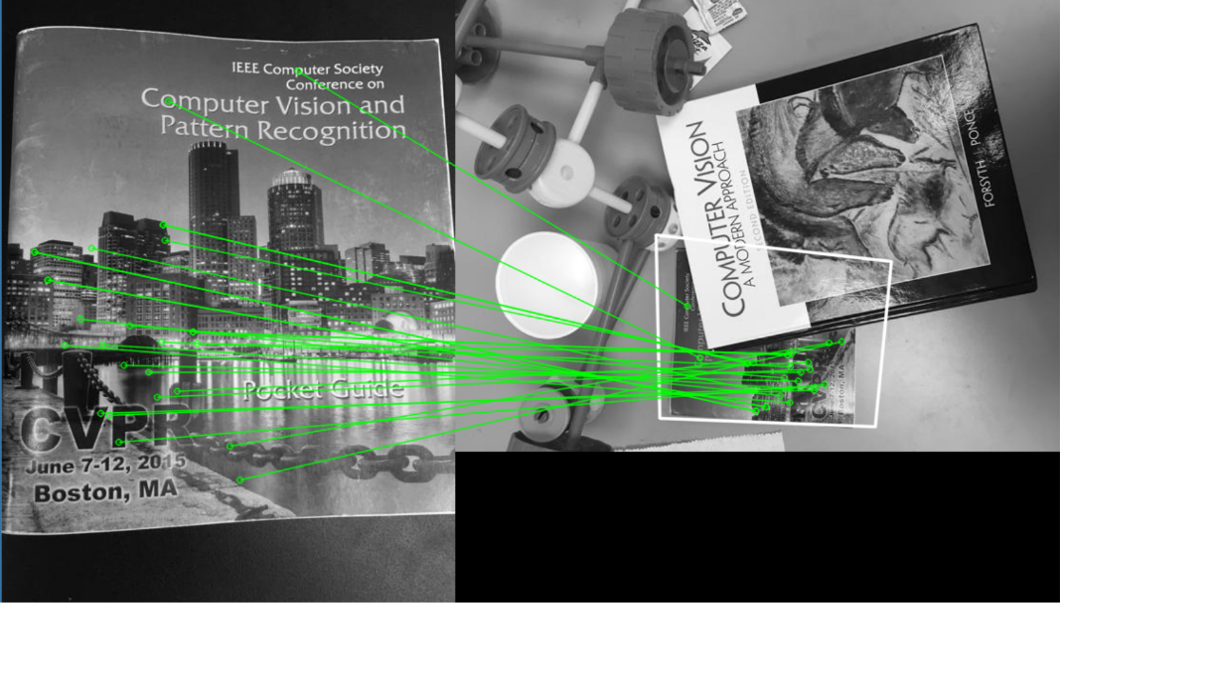**

**Homography Matrix  
Image_1 & Image_3:  
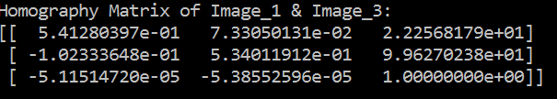  
  
  
Image_1 & Image_4:  
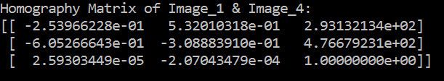  
  
Image_1 & Image_5:  
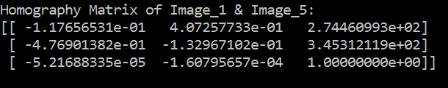  
  
Image_2 & Image_3:  
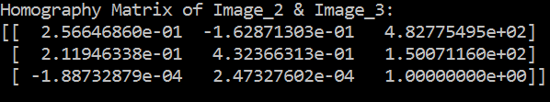  
  
Image_2 & Image_4:  
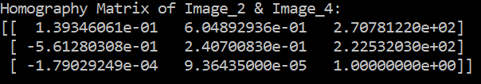  
  
Image_2 & Image_5:  
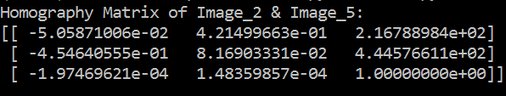**

**Analysis**

**Observation:**The method works well for the given sets of query and train images. What follows are some of the interesting observations from the experiment:

* The top 20 scoring matches found by the matcher before RANSAC operation is applied is more precise for Image_1 compared to Image_2. This is quite evident from our observation while querying for Image_2 in Image_5.
* The spatial distribution of the features is better for Image_2 when compared to Image_1. In our observation for all of the query images Image_1 has a small subset/section to which the features often belong to.
* Although there is a full exposure of the train image- Image_1 in both Image_5 and Image_3, Image_5 has a more spatially distributed matching when queried for Image_1.

**Inference:**

* The reason for the lesser spatial distribution of matches for Image_1 is fairly easy to understand. The sharp change in pixel intensities are far less in the image cover than in the text. Thus, the dominant features are often picked up from the text section of the image.
* Detection of Image_1 on Image_5 is more distributed than that on other queries. The intuition behind this is that in Image_4 and Image_3 most section of Image_1 is cluttered because of over-illumination. For this reason, we don’t find the dominant features to be existing on this section of the image.
* The reason why the matches are more precise for Image_1 when compared to Image_2 on the same set of query images is because, in Image_1 can be seen as a layer of grey/black pixels on a white canvas while Image_2 is the inverse. The matcher thus matches ambiguous pixel changes in the background more often for Image_2 when compared to Image_1.